THE FUTURE OF AGRICULTURE-THE AGRIBOT

Developed by INFINITE LOOP

In Modern world, Automation robot is used in many of the fields such as defence, surveillance, medical field, industries and so on. In our Project, the robot system is used to develop the process of cultivating agricultural land without the use of man power. The aim of the Project is to reduce the man power, time and increase the productivity rate.

All the basic automation robot works like weeding, harvesting and so on. Here the designing systems like plough the land, sowing the seed, watering the plant or spraying the fertilizer and navigate the vehicle motion are preferred by this autonomous robot using microcontroller

In the field of agriculture, plantation begins with ploughing the land and sowing seeds. The old traditional method plough attached to an animal i.e., ox or cow and tractors needs human involvement to carry the process.

The driving force behind this work is to reduce the human interference in the field of agriculture and to make it cost effective. In this work, a part of the land is taken into consideration and the robot introduced localizes the path and can navigate itself without human action. For ploughing, this robot is provided with tentacles attached with saw blades. The sowing mechanism initiates with long toothed gears actuated with motors.

The complete body is divided into two parts the tail part acts as a container for seeds. The successor holds on all the electronics used for automating and actuation. The movement of our robot is provided with wheels covered under conveyor belts. Gears at the back of the robot rotate in equal speed with respect to each other with the saw blades. For each rotation every tooth on gear will take seeds and will drop them on field.

REQUIREMENTS FOR AGRIBOT

1.Humidity Sensor:

Humidity Sensor is used to measure the humidity level and also senses, measures, reports both moisture and air temperature.

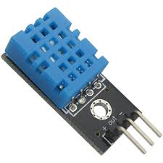

2.Soil Moisture Sensor:

Soil moisture sensors measure the volumetric [water content](https://en.wikipedia.org/wiki/Water_content) in [soil](https://en.wikipedia.org/wiki/Soil) and it is also give whether the crop is Cultivated in correct soil moisture content to our Farmers.

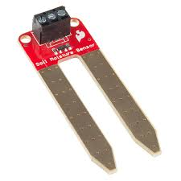

3.Ultrasonic Sensor:

Based on movement of this robot in the land, the ultrasonic sensor helps in obstacle detection, thereby performs turning the position of robot either in left or right or forward direction. The navigation part has been done in simulation with the help of proteus.

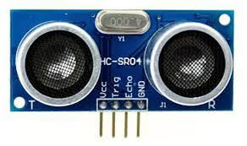

4.GSM Module:

The Global System for Mobile Communication is used to Receiving the messages from Robot to our Mobiles Whether Any Obstacles Created. By Making Use of it, we Will Always Receive regular updates of our Agribot.

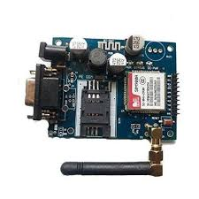

5.DC Motors:

These Motors Are Used to Run the Robot i.e., Going Forward, Backward, Right or left. DC Motor Capacity is 12 Volt Power So that the robot Will Move from One position to Another. 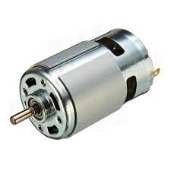

6.General Tools (Chassis, Tires, Wires):

The Chassis is the base frame of The AgriBot, Maintains All the Sensors in the Top. The Tires Is required for Movement and All the Sensors is connected through the Wires Called Jumpers.

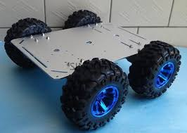

Thus Requirements Are Finished for AgriBot.

Note:

We Also Controlled the AgriBot Using Our Mobile Phones by Using Mobile Application Through Voice Recognition.

Two in One:

* + - Controlled Automatically
    - Controlled Manually by Simply using Mobile Phones.

FINAL LOOK OF AGRIBOT LOOK LIKE THIS

